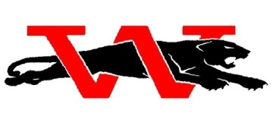
WESTMOORE JAGUARS

2023 BOY’S BASKETBALL CAMP

DATE: May 30th-June 1st (Tuesday-Thursday)
TIME: 9am-Noon (3rd -8th graders) 2023-’24 SCHOOL YEAR

PLACE: WESTMOORE HIGH SCHOOL – 12613 SOUTH WESTERN OKC, OK

The camp will focus on and include:
- FUNDAMENTALS (ball handling, shooting, passing)
- DECISION MAKING IN GAME-LIKE SITUATIONS
- SHOOTING COMPETITIONS
- FOOTWORK
- DAILY COMPETITIONS AND COMPETITIVE GAMES
- CAMPERS THAT PRE-REGISTER WILL BE GUARANTEED A CAMP SHIRT IN THEIR SIZE

CAMP WILL BE CONDUCTED BY THE WESTMOORE HS BOYS VARSITY COACHING STAFF AND THE 2023-24 JAGUARS VARSITY PLAYERS.

HOW TO ENROLL:
Mail a $50 deposit or send the full payment of $100 to reserve your camper’s spot.
Detach the bottom portion and return cash or check (blue or black ink only) to:
JAGUAR BASKETBALL CAMP
C/O Todd Millwee
12613 S. Western
Oklahoma City, OK 73170
**Make Checks payable to: Moore Athletics

-----------------------------------Detach and return with payment------------------------------------------------------------

NAME ___________________________________ AGE _________ GRADE ______ (2023-24 School Year)

ADDRESS _________________________________________ CITY _________ ZIP ___________

PARENT/GUARDIAN CELL________________ SHIRT SIZE: YS, YM, YL, S, M, L

Parent/ Guardian hereby agrees to accept all responsibility for medical or other expenses that might occur.
***Parent/Guardian signature is required: __________________________________________

**Email michaelmillwee@mooreschools.com with questions. Or text 580-284-4006
STAFF USE ONLY

VISIT OUR WEBSITE WESTMOOREBASKETBALL.ORG FOR MORE

